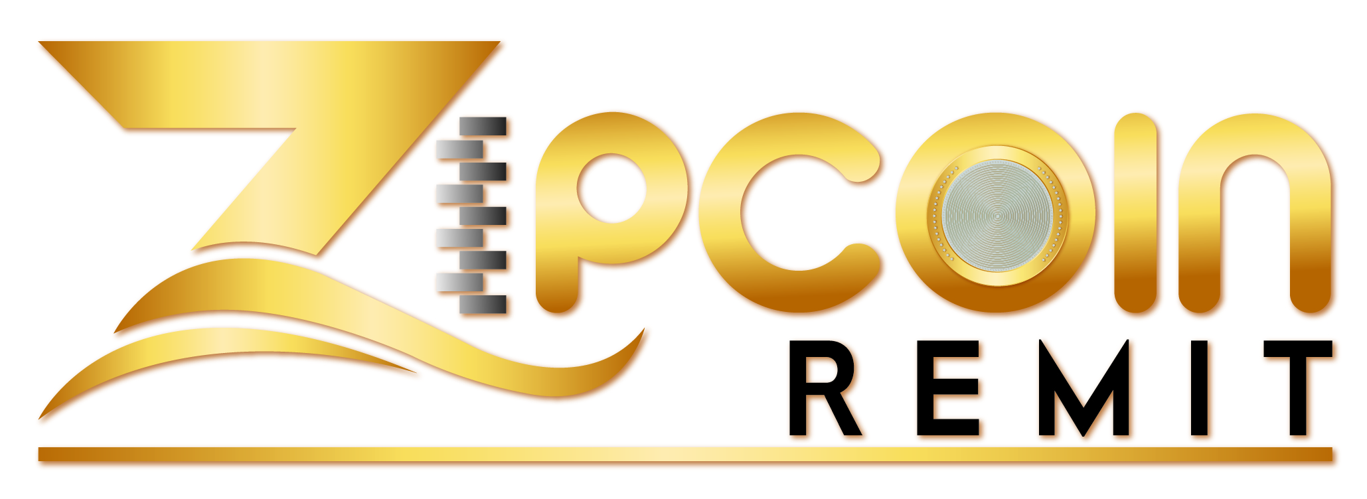

**ZIPCOIN REMIT**

**Privacy Policy**

Your **Choice** Matters.

**Remit** More. **Pay** Less.

Table of Contents

1. ZipCoin Remit Privacy Policy 4

2. How do we protect your personal information? 4

3. Information We May Collect 5

4. Why We Collect Information 6

5. How We Share Information With Others 7

6. Access To Your Information 7

7. Security 7

8. Links to 3rd Party Sites 8

9. Chat 8

10. Social Media Widgets 8

11. Import Contacts 8

12. Referrals 8

13. Complaints 8

14. Contact 9

# 

Privacy Policy

Last Updated: 15 April 2019

# ZipCoin Remit Privacy Policy

This “Privacy Policy”, or “Policy” explains what you can expect from “ZipCoin Remit”, or “ZipCoin Remit”, or “us” and what we need from you in relation to your personal data. Please read this carefully as this policy is legally binding when you use our Services. Check the [Customer Agreement](https://transferwise.com/terms-of-use) for the meaning of defined words (those with capital letters).

For the purpose of the relevant data protection regulations, ZipCoin Remit Ltd are the “data controller” of your information. ZipCoin Remit Ltd. is a Canadian company formed in the Province of Alberta. Our registration number is **2021372194** and FINTRAC registration # is **M 18463842**. If you have any questions about how we protect or use your data, please email us at [compliance@zipcoinremit.com](mailto:compliance@zipcoinremit.com)

# How do we protect your personal information?

1. We are serious about guarding the security of your personal information and use a secure server to store your personal information. All information you provide to us is stored on our secure servers. Any payment transactions will be encrypted using Transport Layer Security technology.
2. As you will know, the transmission of information via the internet is not completely secure. Although we will do our best to protect your personal data, we cannot guarantee the security of your data during transmission, and any transmission is at your own risk. Once we have received your information, we will use strict procedures and security features to try to prevent unauthorized access.
3. We restrict access of your personal information to those employees of ZipCoin Remit who have a business reason for knowing such information. We continuously educate and train our employees about the importance of confidentiality and privacy of customer information. We maintain physical, electronic and procedural safeguards that comply with the relevant laws and regulations to protect your personal information from unauthorized access.

We may amend this Policy at any time, and whenever we do so we will notify you by posting a revised version on the Website. If, however, we plan to make a material change in the way we collect, use, or store your Personal Information, we will provide prior notice on our website, and by email. You will then have the chance to decide whether or not we will use or disclose your information in that new manner, whether through an “opt-out” procedure or by terminating your relationship with us. Such changes will become effective, at the earliest, 30 days after the date of the email notifications.

We ask that minors refrain from using our Service or submitting any Personal Information to us. Minors (those under the age of 18 years) are not eligible to use our Service.

If you have questions or concerns regarding this Policy, you should contact us.

# Information We May Collect

We will collect the following information about you, which may include non-public Personal Information:

* Personal and financial Information you give us as a result of using the Service, such as your address, e-mail address, date of birth, telephone number, all or part of your Social Insurance number, bank account number, bank account information, and credit/debit card number. Under certain circumstances we will also collect and save information obtained from scanned copies of official identification documents, including your Passport or Drivers' License.
* Third party Personal Information you provide in order for us to facilitate funds transfers, such as your recipient's full name, physical address, email address, and phone number. However, we will not contact your recipients except as instructed by you or as required to complete a transaction. This information is only used for the sole purpose of completing your request or for whatever reason it may have been provided.
* Information about your usage of the Service, including your transaction history, and how and to whom you use the Service to send or receive money.
* Information that we lawfully obtain from third parties, such as identity verification services, electronic database services, and credit reporting agencies.
* Information that we indirectly obtain from you, such as information about the hardware and software you use when accessing the Service, your IP address, and the pages you access on this website, and other websites that you visit prior to accessing the Service.
* Technologies such as: cookies, beacons, tags and scripts are used by ZipCoin Remit Canada, Inc. and our marketing, analytics and risk partners or affiliates. These technologies are used in analyzing trends, administering the site, tracking users' movements around the site and to gather demographic information about our user base as a whole. We may receive reports based on the use of these technologies by these companies on an individual as well as aggregated basis.
* We use cookies for site functionality, remembering user's settings (e.g., source & destination country), and for authentication. Users can control the use of cookies at the individual browser level. If you reject cookies some features, or areas of our site will be limited.
* As is true of most web sites, we gather certain information automatically and store it in log files. This information may include internet protocol (IP) addresses, browser type, internet service provider (ISP), referring/exit pages, operating system, date/time stamp, and/or clickstream data.
* We may combine this automatically collected log information with other information we collect about you. We do this to improve services we offer you.
* We use Local Storage Objects (LSOs) such as HTML5 to store content information and preferences. Third parties with whom we partner to provide certain features on our site or to display advertising based upon your Web browsing activity use LSOs such as HTML 5 or Flash to collect and store information.
* Various browsers may offer their own management tools for removing HTML5 LSOs. To manage Flash LSOs please [click here](http://www.macromedia.com/support/documentation/en/flashplayer/help/settings_manager07.html).
* We partner with a third party to manage our advertising on other sites. Our third-party partner may use technologies such as cookies to gather information about your activities on this site and other sites in order to provide you advertising based upon your browsing activities and interests. If you wish to not have this information used for the purpose of serving you interest-based ads, you may opt-out by [clicking here](http://preferences-mgr.truste.com/). Please note this does not opt you out of being served ads. You will continue to receive generic ads.

# Why We Collect Information

* We collect Personal and Non-Personal information for the following purposes:
* To process your transactions.
* To verify your identity.
* To collect payment for your use of the Service.
* To troubleshoot problems with the Service.
* To comply with applicable laws and regulations, such as those relating to “know-your-customer,” terrorist financing, and anti-money laundering requirements.
* To detect and prevent fraud and other illegal uses of the Service.
* To send you marketing notices, service updates, and promotional offers.
* To collect survey information that will be used to monitor or improve the use of our Service and overall customer satisfaction.
* We transfer, store, and process your personal data in the United States and other international jurisdictions to provide you the Service and perform its obligations under this and related agreements. The applicable privacy laws of those other international jurisdictions may differ from those in Canada. We will retain your information for as long as your account is active or as needed to provide you Service. We will retain and use your information as necessary to comply with our legal obligations, resolve disputes, and enforce our agreements.

# How We Share Information With Others

* We will share your Personal Information with third parties only in the ways that are described in this privacy policy. We do not sell or rent the information we collect to third parties for their promotional purposes. These companies are authorized to use your personally identifiable information only as necessary to provide these services to us.
* Nevertheless, we may share information about you (including nonpublic, Personal Information) with:
* Third-party service providers under contract with ZipCoin Remit that help us with our business operations, such as transaction processing, fraud prevention, and marketing. These third parties are prohibited from using your information for their own separate business purposes.
* In the event of the sale, acquisition or merger of some or all of our assets, your Personal Information might be a part of the transferred assets. We shall notify you in the event of such an occurrence, as well as any choices you may have regarding your Personal Information, by placing a notice on our website.
* Law enforcement, government officials or other third parties, but only
* in connection with a formal request, subpoena, court order, or similar legal procedure; and,
* when we believe in good faith that disclosure is necessary to comply with the law, prevent physical harm or financial loss, report suspected illegal activity, or to investigate violations of our User Agreement.

# Access To Your Information

You can access, modify, delete or update your Personal Information submitted on our Website by logging into your account and changing your preferences, by emailing our Customer Support at support@zipcoinremit.com or by contacting us by telephone at the contact information listed below. We will respond to your request to access within a reasonable timeframe.

# Security

We employ industry accepted standards in protecting the information you submit to us on our Website. We have put in place SSL (Secure Socket Layer) encryption technology to protect your sensitive information such as bank account number, credit or debit card number, date of birth, and Social Insurance Number, transmitted through our Website. We also require a username and password from each user who wants to access their information on our Website. However, no method of transmission over the Internet, or method of electronic storage, is 100% secure. Therefore, we cannot guarantee its absolute security. If you have any questions about security on our Web site, you can contact us at support@zipcoinremit.com

* You may opt-out from promotional emails to you by selecting the “Unsubscribe” function present in each promotional email we send you. As we are required to contact you in certain occasions, such as to provide confirmation of a transaction, changes in account details, or to verify your identify, you may not opt-out of all emails.

# Links to 3rd Party Sites

Our Site includes links to other Web sites whose privacy practices may differ from those of ZipCoin Remit Ltd. If you submit Personal Information to any of those sites, your information is governed by their privacy policies. We encourage you to carefully read the privacy policy of any Web site you visit.

# Chat

We use a chat feature to answer questions about our service and assist you with our website's functionality. If our chat feature is offline we will collect your name and email address so that we may reply to your request.

# Social Media Widgets

Our Web site may include Social Media Features, such as the Facebook Like button and Widgets, such as the Share this button or interactive mini-programs that run on our site. These Features may collect your IP address, which page you are visiting on our site, and may set a cookie to enable the Feature to function properly. Social Media Features and Widgets are either hosted by a third party or hosted directly on our Site. Your interactions with these Features are governed by the privacy policy of the company providing it.

# Import Contacts

You can import contacts from your mobile phone, Gmail, and/or Yahoo Mail to invite them to become members of our site. We do not collect the username and password for the email account you wish to import your contacts from as you provide it directly to Gmail or Yahoo and after your approval they send us your email contacts. At your instruction we will send at most one email invite.

# Referrals

If you choose to use our referral service to tell a friend, family member, or other personal connection about our site, we will ask you for their name and email address. We will automatically send your friend an email and at most one reminder email inviting him or her to visit the site. ZipCoin Remit Canada, Inc. stores this information for the sole purpose of sending this email and tracking the success of your referral.

Your friend may request that we remove this information from our database.

# Complaints

If you have a complaint, contact ZipCoin Remit Compliance Office, online live chat via: *tawk.to* or by phone 1-403-389-6948 or by email at compliance@zipcoinremit.com

# Contact

You can contact us with any questions or concerns at: ***ZipCoin Remit Ltd. Canada, P. O Box 47068 Creekside; 20 12192 Symons Valley Rd; Calgary; AB T3R 0A0***

**Email:** Customer Service(service@zipcoinremit.com)

**Office Phone Number:** +1-587-393-6400

